**Flow Chart of Bus Ticket Reservation:**

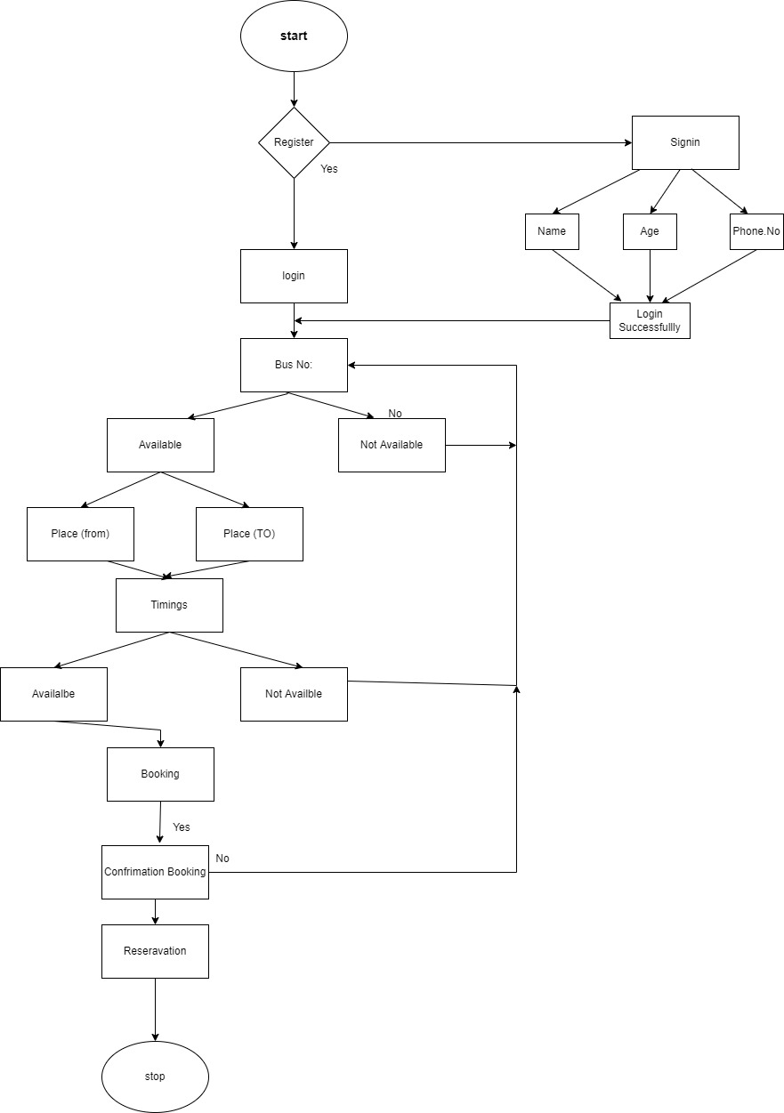

**Block Diagram:**

